13.1 Data:
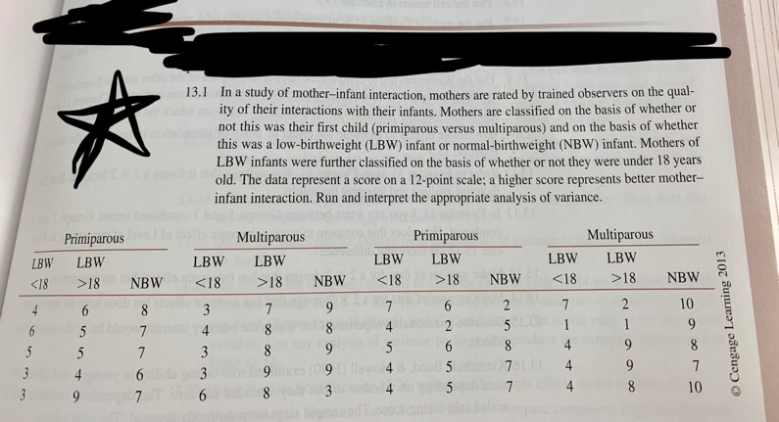

Questions: Answer each part using data from Exercise 13.1 in Howell:

- Rearrange the data in a table similar to Table 13.4-a (p. 421), showing cell means, each factor’s marginal means, and the grand mean (i.e., overall mean). You don’t need to include the raw data in the table.

- Use Excel, Word, or R (but not using SPSS) to construct a plot that has Birth Weight on the horizontal axis and separate lines for the two levels of Parity. The plot should contain both the cell means and marginal means, and the lines should be meaningfully labeled (e.g., primiparous).

- Complete the following ANOVA table by hand computation. Please show your work.

Source | df | SS | MS | F | Critical Value  ($α=.05$)
Parity
Birth Weight
Interaction
Error |  | 210.400
Total |  | 338.933

- [SPSS] Run ANOVA analysis using SPSS. Please rename the dummy variables related to each factor appropriately prior to running the analysis. Copy and paste the ANOVA table and highlight the rows that correspond to the ones in Part c. Also, copy and paste the summary table and label the cell means, marginal means, and grand mean using the statistical notation in your textbook. For labeling, consider using callouts (i.e., speech bubbles).

- [SPSS] Use simple effects to compare the three groups of multiparous mothers and report the appropriate statistics (use $α=.05)$. What conclusions can you draw from this analysis?

- [SPSS] Conduct all pairwise comparisons among the means of the three groups of multiparous mothers. Make sure the familywise error rate does not exceed $α=.05$ with the Bonferroni correction. Copy and paste the relevant SPSS outputs and interpret your results.

- By taking into account the various pieces of information from your analysis, what statistical conclusions can you draw from the study? Provide a full write-up in which you interpret all of the findings.

- Compute partial ${\hat{η}}^{2}$ for the effect of interaction by hand and explain its meaning.

- [GPower] Compute the power for interaction using the computer package GPower. Include a screenshot (not a picture from your phone) of GPower that clearly shows the inputs and outputs. Interpret the result.

This is a post hoc power analysis

When you interpret the result:
- How strong is the power relative to the generally desired level?
- What is power the probability of?
- What does the power say about the replicability of the study?

